**GEORGE FLOYD FOUR YEARS AFTER: A DATA DRIVEN ANALYSIS OF POSTS AND COMMENTS ON X (FORMERLY TWITTER)**

By

Apampa, O.R.

(Email: [apamps2000@gmail.com](mailto:apamps2000@gmail.com))

***Abstract***

The death of George Floyd in the hands of the Minneapolis Police on the 25th of May 2020 led to public outcry, followed by a worldwide protest against the rampant killing and humiliation of black people by the Police in the western hemisphere, especially in the United States.

The objectives of study were to use data mining techniques and machine learning algorithms to better understand how the online communications emanating from Twitter (now X) trended during the period of the protests, and the observed characteristics of these communications.

Due to the large volume of data collected from the social media platforms X, two separated datasets in the forms of posts (formerly known as tweets) were collected in DataFrame format using the Twitter Archival Google Sheets (TAGS). The first dataset was collected using *#BlackLivesMatter*, and the second using *#GeorgeFloyd*. Using modules from the Python ecosystem specifically designed for data analytics, operations such as sentiment analysis, word count and data visualisations such as word cloud were made possible. The social network package Gephi was found most suitable for analysing the network that evolved over the period under review.

Our social media analytics of the #BlackLivesMatter dataset showed that 40% of the tweets analyzed were positive, 44% were found to be neutral, and only 21% were categorized as negative by the TextBlob algorithm. A simple network was observed to have evolved due to the proximity in location of social media handles.

Using the #GeorgeFloyd dataset, our analysis showed that 39% of the tweets were positive, another 39% were found to be neutral, and only 22% were considered negative by the algorithm for sentiment analysis this time around. Overall, the commentaries on twitter were found to be positive and in support of the protests and clamour for change, social justice, police reforms, equality, and equity.

***Keywords:*** BlackLivesMatter, George Floyd, social media, social network analysis, sentiment analysis, social media movements, Twitter, tweets

**Introduction**

On Monday the 25th of May 2020, George Floyd, a 46 years old African American was killed in Police custody in Minneapolis, the United States of America in broad daylight. Thus, sparking outrage and condemnation leading to a worldwide protest by members of the Black Lives Matter movement (BLM) and their supporters. Most people were outraged at the video of the incident that went viral on social media whereby Minneapolis Police officer Derek Chauvin knelt over George Floyd by the neck with is knees for a total of 8 minutes and 46 seconds while Mr. Floyd pleaded for mercy and his life, stating severally that he could not breathe. He eventually passed out and was pronounced dead on arrival at the hospital.

Unlike previous protests, the protests following the death of Mr. Floyd went on for several days and weeks. By the end of June 2020, BLM protests had taken place in all 50 states of the U.S. Protests also broke out in the city of London, the United Kingdom; Paris, France; Berlin, Germany; Madrid Spain; Melbourne Australia; Amsterdam, the Netherlands; Johannesburg, South Africa; Lagos, Nigeria and Rio De Janeiro Brazil. As of August 2020, BLM protests were still ongoing in the United States notably in the State of Washington which is predominately white demographically.

**Aims and objectives of study**

The objective of study is to use big data analytics (data mining techniques and the use of machine learning algorithms) on data collected from the social media platforms X, in order to better understand how the online communications emanating from X trended during the period of the protests, and the observed characteristics in the form of patterns, opinions, and insights from these communications.

**Literature Review**

Van Osch and Coursaris (2013), reported that “social media” are technology **artefacts**, both material and virtual, that support various **actors** in a multiplicity of communication **activities** for producing user-generated content, developing and maintaining social relationships, or enabling other computer mediated interactions and collaborations”. For the study social media is defined thus:

*Social media are digital platforms that are accessible via web browsers or mobile applications, that may (or may not) allow an individual to create a personal profile such that they can connect with other users on the platform for communication, collaboration, sharing of user generated contents, development and sustenance of interpersonal relationships and other well-defined forms of social interactions in a specified social context.*

According to (Bruns *et al*, 2014), social media are often also described as social networks. Although the two terms do not mean the same thing, they are closely related. To briefly define the two:

***Social media:*** the communicative aspects of platforms. This means both the media we create – the tweets on Twitter, images on Instagram, and videos on YouTube – as well as the information, ideas, and opinions we communicate through these media.

***Social networks*:** the interconnections between people on platforms. These connections are created by and used in these communicative processes, as well as the interconnections between posts, comments, and other pieces of content we create.

The likes of YouTube, Vimeo and Vevo have been categorized as Vlogs (video blogs) due to their video sharing architecture that also makes room for responses and comments by users and followers. It is obvious from the above descriptions that the many social media platforms that are available for free usage today allows different modes of interactions and content sharing amongst users. Typically blogs and vlogs offer interaction between a blogger (owner, operator, or manager of a weblog) and followers or users in a restricted kind of network. While the likes of Facebook and Twitter have ecosystems that allow for across user interactions in a defined network. Instagram is a mobile application that allows for the sharing of contents (images and videos) amongst users, with room for comments. It must be pointed out that Instagram is accessible online as a website via a web browser, it is nonetheless essentially a mobile application with a limited web version.

***Social media movements:*** Sandoval-Almazan, R., and Gil-Garcia, J.R. (2014) reported that Information technologies were increasingly important for political and social activism, such that social media applications have recently played a significant role in influencing government decision making and shaping the relationships between governments, citizens, politicians, and other social actors. This view was corroborated by Isa and Himelboim (2018) when they observed that in the last two decades online social movements have been increasingly relying on new communication technologies, and more recently, social media, to mobilize their own members, reaching out to new ones, and engaging with key societal actors, such as news media and decision makers to bring about societal changes. Whether it is referred to as online social movements or social media movements, the use of social media platforms to plan, coordinate, organize and mobilize a group of people effectively to take a stand and effect societal change on a particular issue of collective importance is at the core of social media movements. Ranney (2014) was of the view that a social movement is an entity formed by a group of people who come together to protest injustices and challenge the status quo. Social movements can be local or international and may address various social issues (Isa and Himelboim, 2018).

For the study, the term social media movements (SMM) is preferred because the research work is centred around the formation, sustenance and social architecture of the online social movements that evolved from such mobilization at a specific period. Unlike traditional social movements, SMM challenges the assumption of a movement as a single interconnected component, calling for identifying subgroups within the movement (Isa and Himelboim, 2018). Social-media-based activism tends to be less interconnected, and often composed of distinct and often disconnected subgroups, and publics (Keib & Himelboim, 2016). SMM are driven by key actors who can mobilize ordinary citizens and influential members of the society. As Isa and Himelboim (2018) rightly observed, how social media movements strategically use these key users and post content, to reach out beyond their immediate group of members, remain understudied.

***Advocacy based social media movements:*** Many social media movements (SMM) grew out of a spontaneous response to ongoing social issues that affects a sub-group or cross-section of society, male and female. The #BlackLivesMatter movement is one of such. Formed in the U.S., the BLM has gained traction across the Atlantic to places such as the United Kingdom and mainland Europe as a means of fighting systemic racism towards black people. As Bauermeister (2016) observed that Social movements were often initiated by a group of actors who are the primary victims of a decision, action, or policy that drive them to protest and hold demonstrations. These actors play the leadership role throughout the movement’s life cycle to achieve their goals. The BlackLivesMatter movement is not only engaged in campaigns against Police brutality towards people of African descent, it has called for prison reforms and orientation towards the issues that affects the black communities in the diaspora. It was founded in 2013 by Alicia Garza, Patrisse Cullors and Opal Tometi. Other notable people in the movement includes Shaun King, DeRay Mckensson, Erica Garner, Johnetta Elsie and Tet Pole (<https://en.wikipedia.org/wiki/Black_Lives_Matter>).

**Research Methods**

Due to the large volume of data anticipated from social media platforms (social networks and weblogs), the collected data was subjected to data mining techniques, and the use of machine learning algorithms for sentiment analysis, data visualization and established statistical analysis for inferences for useful insights and knowledge extraction from posts (tweets), reposts (retweets), and comments (replies).

***Data collection:*** Two sets of data were collected from the social media platform Twitter (now X) using the Twitter Archival Google Sheets (TAGS). The first set of data was collected using the hashtag ***#GeorgeFloyd*** between June 1st and June the 14th, 2020. Only one of the two datasets collected was found usable. Thus, the ***#GeorgeFloyd2*** dataset has the attribute (18511, 18).

For the second dataset, two sets of tweets (posts) were collected over a period of four weeks (June 1 till June 28, 2020) using the “#BlackLivesMatter”. The collected tweets were merged into one unit (#BlackLivesMatter2020) using the concatenation method in the Pandas module. The data ***#BlackLivesMatter2020*** has a total of 67,792 instances and 18 columns, but was reduced to (67,792, 17) for further analysis after which the column indices (0) was dropped from the DataFrame using the delete function.

***Data Wrangling and Cleansing:*** The two datasets were then subjected to wrangling and cleansing to prepare them for further analysis. Tokenisation, stemming, lemmatization and the removal of stop words were some of the operations performed on the datasets to prepare them for sentiment and social network analysis.

**Data Analytics:** There are several modules available in the Python ecosystem for data analytics, especially in the areas of social media analysis. Modules such as *Pandas, MatPlotLib, SciPy, SciKitLearn, TextBlob, BS4,* etc all have advanced features for doing sentiment analysis, word cloud, and data visualisation such as word cloud, plots etc.

**Result and Analysis**

***Sentiment Analysis:*** This entails the categorisation of an expression or a piece of text as being positive, negative, or neutral. This is useful in gauging public perception of an item, situation, event, or phenomenon. Using the TextBlob module for sentiment analysis on the BlackLiveMatter2020 data, we have the following.

Table 1: Sentiment Analysis of tweets for #BlackLivesMatter

|  |  |  |
| --- | --- | --- |
| **S/N** | **Id_str** | **Sentiment** |
| 0  1  2  3  4  5  6  7  8  9 | 1269736037766451200  1269736037410095108  1269736037359726598  1269736037254934530  1269736037112299521  1269736036717850624  1269736036629983232  1269736036462141446  1269736036063744006  1269736035950477312 | 0.000000  0.000000  0.014815  0.00000  -0.250000  0.000000  -0.041667  0.000000  0.000000  0.000000 |

Percentage of positive tweets: 33.91698135473212% = **33.9%**

Percentage of neutral tweets: 44.88877743686571% = **44.9%**

Percentage of negative tweets: 21.194241208402172% = **21.2%**

**Total = 100.0%**

***Word Cloud:*** *Below is the most common 500 words in the #BlackLivesMatter data collected analyzed.*

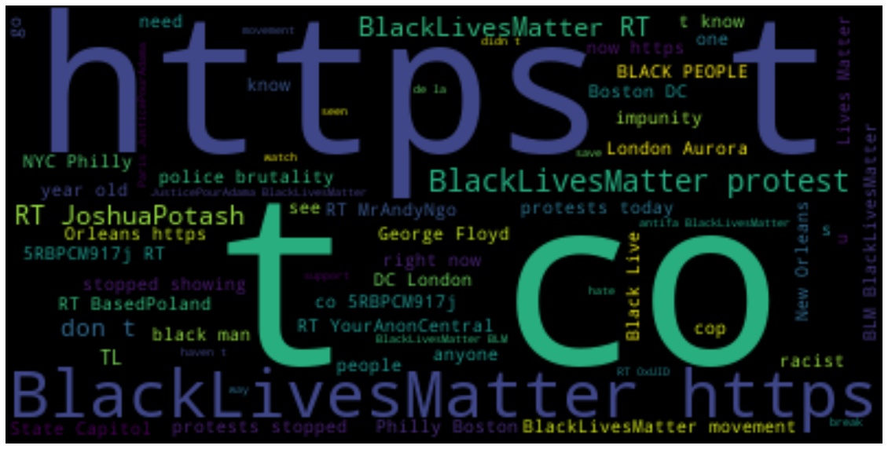

Figure 1: Word Cloud for BlackLivesMatter2020 twitter dataset

***Word Count:*** This reveals the most common words in the tweets in numbers for the collected dataset.

Table 2: Word Count for #BlackLivesMatter2020 dataset

|  |  |  |
| --- | --- | --- |
| **S/N** | **Word** | **Count** |
| 1  2  3  4  5  6  7  8  9  10 | BlackLivesMatter  **#**BlackLivesMatter  Police  Protest  Black  Joshua Potash  London  Movement  Racism  Justice | 48,968  9,493  8,088  7,958  4,774  4,270  3,203  2,742  2,540  2,464 |

**Social Network Analysis for *#BlackLivesMatter* Dataset**

Using the Force Atlas option in Gephi and setting the other parameters to basic options. The following network developed from the #BlackLivesMatter data (fig. 2) below. Clusters were identified communities or sub-networks within the main network. Gephi has built in algorithms to identify and analyse the modularity of a network (that is the tendency of a network to separate into clusters). Table 3.0 below shows the results for some statistical graph measures. It is nonteworthy that the network is not dynamic and is restricted (we consider the network in 30 days only – June of 2020), although in reality such networks keeps growing and the shape keeps changing, thus statistical measures such as Degree and Clustering Coefficient are absent, though we do indeed have clusters (subnetworks) in the graph.

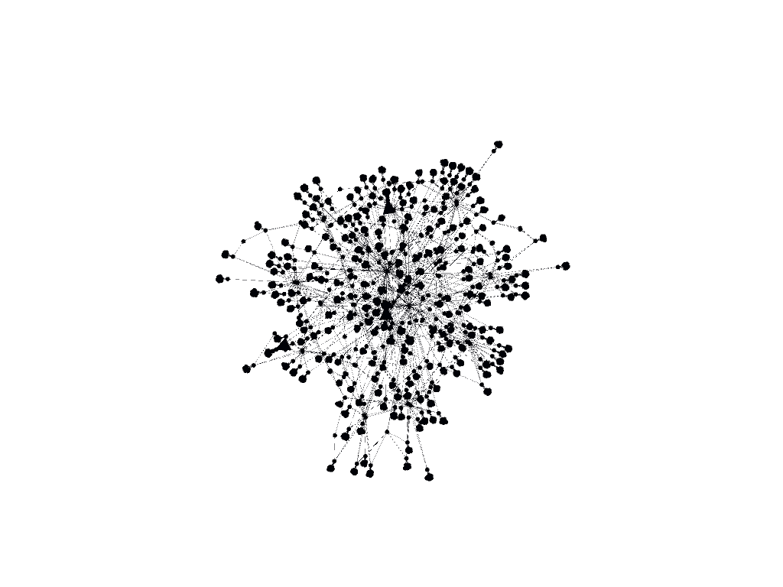

Figure 2: A social network of the #BlackLivesMatter campaign in June 2020.

Analysing the network for the associated parameters revealed the following information as presented in table 3 below.

Table 3: Network parameters for #BlackLivesMatter2020 dataset

|  |  |  |
| --- | --- | --- |
| **S/N** | **Network Parameter** | **Value** |
| 1  2  3  4  5  6 | Average degree  Average weighted degree  Network diameter  Graph density  Modularity  Average path length | 1.249  1.25  8  0.001  0.799  4.94 |

Sentiment Analysis of the ***#GeorgeFloyd2 dataset (18511, 18)*** revealed the following as presented in table 4 below.

Table 4: Sentiment Analysis of tweets for #GeorgeFloyd2 dataset

|  |  |  |
| --- | --- | --- |
| **S/N** | **Id_str** | **Sentiment** |
| 0  1  2  3  4  5  6  7  8  9 | 1272120199685091328  1272120189988020225  1272120185764433920  1272120164071464960  1272120163249410048  1272120149156540418  1272120143015968776  1272120140637696001  1272120132161146880  1272120123558629377 | 0.050000  0.050000  -0.248810  0.000000  0.000000  -0.248810  -0.248810  0.050000  0.000000  -0.140909 |

Percentage of positive tweets: 39.01253241140881% = **39.0%**

Percentage of neutral tweets: 39.37445980985307% = **39.4%**

Percentage of negative tweets: 21.6076058772688% = **21.6%**

**Total = 100.0%**

***Word Cloud:*** *Below is the most common 500 words in the #GeorgeFloyd dataset collected analyzed.*

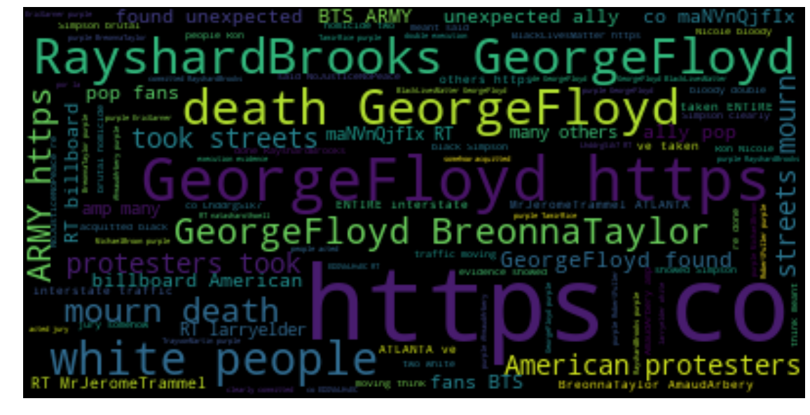

**Figure 3: Word Cloud for *#GeorgeFloyd2* twitter dataset**

***Word Count***

Below is the word count for the most occurring word in the tweets of the #GeorgeFloyd2020 dataset.

Table 5: Word Count for #GeorgeFloyd2

|  |  |  |
| --- | --- | --- |
| **S/N** | **Word** | **Count** |
| 1  2  3  4  5  6  7  8  9  10  11  12  13  14  15 | George Floyd  Purple  Rayshard Brooks  Protesters  Death  Breonna Taylor  BlackLivesMatter  People  Police  White  American  Simpsons  Streets  Mourn  Unexpected | 17155  6652  3509  2995  2933  2891  2698  2618  2600  2087  1956  1927  1827  1697  1696 |

There was no Social Network Analysis conducted for #GeorgeFloyd2 dataset due to the small number of instances available for use. The 18,511 instances in data were insufficient to determine the type of network that resulted over the period of consideration (June 1, 2020 – June 28, 2020).

**Conclusions**

The *#BlackLivesMatter* dataset revealed that 40% of the tweets analyzed were positive, 44% were found to be neutral, and only 21% were categorized as negative by the TextBlob algorithm. Using the *#GeorgeFloyd*, our analysis showed that 39% of the tweets were positive, another 39% were found to be neutral, and only 22% were considered negative by the algorithm for sentiment analysis this time around.

Expectedly, the following words were found to be prominent within the communications in the tweets analyzed; *BlackLivesMatter,* ***#*** *BlackLivesMatter, Police, Protest and Black*. Surprisingly, the name Joshua Potash came up 4,270 times; the city of London 3,203; Movement 2,742; Racism 2,540; and Justice came up 2,464 times. These words were a clear indication of the predominant discussions, posts and views expressed on twitter during the June 2020 protests by the BLM movement on social media. With a modularity of 4.94, a simple social network was found to have emerged during the period under review due to the proximity of Twitter users.

The analysis of tweets collected using the #GeorgeFloyd revealed a different pattern entirely for word count. The name George Floyd was found to have been mentioned a total of 17, 155 times in a 18, 511 tweets – that is 93% of the tweets. The names Rayshard Brooks and Breonna Taylor were prominently mentioned in the tweets. Other prominent words/terms found in the tweets include Protesters, Death, BlackLivesMatter, People, Police, White, American, and Simpsons. The Simpsons was an unexpected term on the list. Available desk reference showed that the name Simpson appeared in many tweets in reference to a debunked episode of the cartoon series “the Simpsons” in which a White Police officer arrested an African American male, and subjected him to a physical situation by placing his knee on his neck thereby leading to protests and riots.

Overall, the protests trended well on X judging from the sentiment analysis conducted. The word count showed that the prominent terms found in the social media communication were in line with the aims and objectives of the #BlackLivesMatter movement, which is primarily about justice, Police reforms, equality before the law and probity.

**References**

Aral, S., Dellarocas, C., Godes, D. (2013). Introduction to the Special Issue—Social Media and Business Transformation: A Framework for Research. *Information Systems Research* 24(1):3-13. <http://dx.doi.org/10.1287/isre.1120.0470>

Aral S, Walker D (2011) Creating social contagion through viral product design: A randomized trial of peer influence in networks. *Management Science*. 57(9):1623–1639.

Aral S, Walker D (2012). Identifying influential and susceptible members of social networks. *Management Science* 337(6092):337–341.

Atefeh, F. and Khreich, W. (2013). A Survey of Techniques for Event Detection in Twitter. *Computational Intelligence*, Volume 0, Number 0. Wiley Periodicals, Inc.

Association of Internet Research (2012). *Ethical Decision Making and Internet Research.* Available at: <http://aoir.org/reports/ethics2.pdf>

Bauermeister, M. R. (2016). Social capital and collective identity in the local food movement. *International Journal of Agricultural Sustainability*, 14, 123–141.

Black Lives Matter Wikipedia page. <https://en.wikipedia.org/wiki/Black_Lives_Matter>

Bogéa, F. and Brito, E.Z. (2017). Determinants of social media adoption by large companies. ALTEC 2017.

Bruns, A., Burgess, J., and Highfield, T. (2014). A ‘Big Data’ Approach to Mapping the Australian Twittersphere. In Arthur, Paul Longley & Bode, Katherine (Eds.) Advancing Digital Humanities: Research, Methods, Theories. Palgrave Macmillan, Houndmills, pp. 113- 129.

Chaudhary, A.K., and Warner, L.A. (2015). Introduction to Social Network Research: Application of Social Network Analysis in Extension. This document is AEC534, one of a series of the Agricultural Education and Communication Department, UF/IFAS Extension. Original publication date February 2015. Visit the EDIS website at http://edis.ifas.ufl.edu.

Christian Fuchs and Daniel Trottier (2015). Towards a theoretical model of social media surveillance in contemporary society. *Communications* 40 (1): 113-135 (2015).

Curry, K. E. (2018). "Politics in the Social Media Era: The Relationship Between Social Media Use and Political Participation During the 2016 United States Presidential Election" (2018). *Dissertations and Theses.* Paper 4506.

Digital Humanities Initiative – Collecting social media data for research. Rutgers University. Available at: [*http://dh.rutgers.edu/collecting-social-media-data-for-research/*](http://dh.rutgers.edu/collecting-social-media-data-for-research/)

# Epple and Schief, S. (2016). Fighting (for) gender equality: the roles of social movements and power resources. ***Interface****: a journal for and about social movements Volume 8 (2): 394 - 432 (November 2016).*

Ghosh, R. and Lerman, K. (2010). Predicting Influential Users in Online Social Networks. The fourth SNA-KDD Workshop Held in conjunction with The 16th ACM SIGKDD International Conference on Knowledge Discovery and Data Mining (KDD 2010). Available @: https://arxiv.org/abs/1005.4882

Guo, S., Wang, M. and Leskovec, J. (2011). The Role of Social Networks in Online Shopping: Information Passing, Price of Trust, and Consumer Choice. *EC* ’11, June 5-9, 2011, San Jose, California, USA. ACM 978-1-4503-0261-6/11/06

Hajli, M.N. (2014).A study of the impact of social media on consumers. *International Journal of Market Research (IJMR),* Vol: 56, Issue: 3.

Hawksey, M. TAGS. Available at: [*https://mashe.hawksey.info/category/tags/*](https://mashe.hawksey.info/category/tags/)

Hettiarachchi H.A.H., Wickramasinghe C.N., Ranathunga S. (2018). The Influence of Social Commerce on Consumer Decisions. *The International Technology Management Review*, Vol. 7 (2018), No. 1, 47-58.

Ibimilua F.O, & Ibimilua, A.F. (2014). Environmental Challenges in Nigeria: Typology, Spatial Distribution, Repercussions’ and way Forward. *American International Journal of Social Science*. Vol. 3, No: 2, March 2014.

Isa, D. and Himelboim, I. (2018). A Social Networks Approach to Online Social Movement: Social Mediators and Mediated Content in #FreeAJStaff Twitter Network*. Social Media + Society*, January-March 2018: 1–14.

Jenders, M. Kasneci, G. and Naumann, F. (2013). Analyzing and Predicting Viral Tweets. International World Wide Web Conference. WWW 2013 Companion, May 13–17, 2013, Rio de Janeiro, Brazil. ACM 978-1-4503-2038-2/13/05. DOI: 10.1145/2487788.2488017

Keib, K & Himelboim, I. (2016) Important Tweets Matter; Predicting Retweets in the #Blacklivesmatter Talk on Twitter. Presented at the AEJMC national conference held in Minneapolis, MN. CTEC Division.

Langer, E. (2014). What’s Trending? Social Media and its Effects on Organizational Communication. *UW-L Journal of Undergraduate Research XVII (2014)*

Milan, S. and Guteirrez (2015). Citizens’ media meets big data: the emergence of data activism. ENERO – June 2015.

Milan, S. and Van der Velden, L. (2016). The Alternative Epistemologies of Data Activism. *Digital Culture and Society,* Vol. 2, Issue 2.

Milan, S. (2016). Media Activism in the Digital Age: Charting an Evolving Field of

Research, edited by Goubin Yang and Viktor Pickard, Shaping Inquiry in Culture,

*Communication and Media Studies Series*, series editor Barbie Zelizer, Routledge (2016)

Miller, J. (2018). "Digital Citizenship Tools for Cause-Based Campaigns: A Broadened Spectrum of Social Media Engagement and Participation-Scale Methodology" (2018). *Electronic Theses and Dissertations*. 6022. <http://stars.library.ucf.edu/etd/6022>

Pasquinelli, M. (2013). Media Activism: Strategie E Pratiche Della Comunicazione Indipendente(Roma: Derivepprodi, 2002); Stefania Milan, *Social Movements and Their Technologies: Wiring Social Change* (Palgrave Macmillan, 2013).

# Pew Research Center (2017). Key trends in social and digital news media. Retrieved from:

[https://www.pewresearch.org/fact-tank/2017/10/04/key-trends-in-social-and- digital-news- media/](https://www.pewresearch.org/fact-tank/2017/10/04/key-trends-in-social-and-%09digital-news-%09media/)

Pigott, F. (2018). Do more with twitter data. Available at: [*https://twitterdev.github.io/do_more_with_twitter_data/finding_the_right_data.ht ml*](https://twitterdev.github.io/do_more_with_twitter_data/finding_the_right_data.ht%09ml)

Ranney, K. (2014). Social media use and collective identity within the occupy movement (Doctoral dissertation). University of Hawaii at Manoa, Honolulu, HI. Retrieved from https:// scholarspace.manoa.hawaii.edu/bitstream/10125/101130/1/ Ranney_Kathryn_r.pdf

Raven, P. H.; Berg, L. R. & Hassenshal, D. M. (2010). Environment. New Jersey, Wiley.

Santra, S. C. (2011). Environmental science (2nd ed.) Kalkata: New Central Book Agency.

Renzi, A., and Langlois, G. (2015): “Data Activism.” In: Greg Elmer/ Ganaele Langlois/Joanna Redden (eds.), Compromised Data: From Social Media to Big Data, London: Bloomsbury, pp. 202–25.

# Sandoval-Almazan, R., and Gil-Garcia, J.R. (2014). Towards cyberactivism 2.0? Understanding the use of social media and other information technologies for political activism and social movements. [*Government Information Quarterly*](https://www.sciencedirect.com/science/journal/0740624X)*,* [Volume 31, Issue 3](https://www.sciencedirect.com/science/journal/0740624X/31/3), July 2014, Pages 365-378

Sundararajan A, Provost F, Oestreicher-Singer G, Aral S (2013) Information in digital, economic and social networks. *Information Systems Research*. Forthcoming.

TAGs 1.6 by Martin Hawksey. Available at: *https://tags.hawksey.info/get-tags/*

Tounsend, L. and Wallace, C. Social Media Research: A guide to ethics. University of Aberdeen. Available at <https://www.gla.ac.uk/media/media_487729_en.pdf>

Trottier, D. and Fuchs, C. (2015). Theorising Social Media, Politics and the State An Introduction. Retrieved from: [https://www.dhi.ac.uk/san/waysofbeing/data/economy-crone-trottier- 2015.pdf](https://www.dhi.ac.uk/san/waysofbeing/data/economy-crone-trottier-%092015.pdf)

Van Osch, W. and Coursaris, C.K. (2013). Organizational Social Media: A Comprehensive Framework and Research Agenda. 46th Hawaii International Conference on System Sciences (DOI 10.1109/HICSS.2013.439).

Wang, H., Tong, L., Takeuchi, R. and George, G. (2016). Corporate Social Responsibility: an overview and new research directions. Editorial - Thematic issue on corporate social responsibility. *Academy of Management Journal*. Vol. 59, No. 2, 534–544. <http://dx.doi.org/10.5465/amj.2016.5001>

Wisdom, V. and Gupta, R. (2016). An introduction to Twitter Data Analysis in Python. Available at: [*https://www.researchgate.net/publication/308371781*](https://www.researchgate.net/publication/308371781)

Xiong, Y., Cho, M., Boatwright, B. (2019). Hashtag activism and message frames among social movement organizations: Semantic network analysis and thematic analysis of Twitter during the #MeToo movement. *Public Relations Review,* [*Volume 45, Issue 1*](https://www.sciencedirect.com/science/journal/03638111/45/1)*, March 2019, Pages 10-23.*